#IMPLEMENT 8 – PUZZLE PROBLEM USING
- DFS

output:
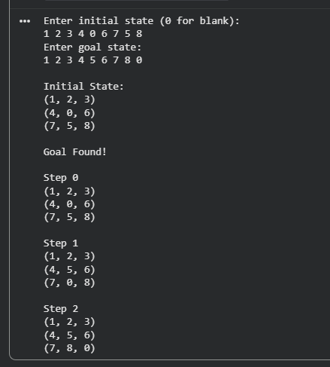

2) Using IDFS

